Message Center – SHMI Displays with 5 Button Interface – CGEA 1.3

Functional Description

The STSS is specific to J73 program with S2.8 and SX variations. See Section 1.3.3.1 Visual for graphic details.

The entire display will be color and the illumination will be dimmable in compliance with the Ford corporate dimming strategy.

The customer will interface and control the information on the display via the five-button message center switch (UP, DOWN, LEFT, RIGHT, and OK), which is located on the steering wheel, remote from the Instrument Cluster.

All information can be displayed in English units or metric units and the text can be displayed in English, Spanish, or French. Additional languages can be provided on a program-specific basis. The Settings menu is used to select the language and the units of measure.

Information displayed typically falls into two categories:

- Information on Demand (IOD’s) (Trip Fuel, Off Road, Towing)
- Lists: Audio, Phone, Vehicle Status, Settings

This document defines "superset" content for the SHMI display Message Centers with 5 button interfaces. Specific program or vehicle content may not include all content defined in this document.

Interfaces

Interface Context Diagram

Inputs

IR-REQ-385384/A-INTERNAL
Reference section 1.2.1 Interface diagram:
- Message Center Switch (UP, DOWN, LEFT, RIGHT, and OK)
- MUX messages on the HS_CAN and ICAN Networks
- Startup_Shutdown_State
- Hardwire input signals
- Speedo_Cal_Cfg

MUX messages

SIG-REQ-385327/A-Veh_V_ActlEng Signal

Signal Name | Size (bits) | Detail | Units | Res. | Offset | State  Encoded | Min | Max
Veh_V_ActlEng | 16 |  | KPH | 0.01 | 0 |  | -0  (0x0000) | 655.35 (0xFFFF)

SIG-REQ-385326/A-VehVActlEng_D_Qf Signal

Signal Name | Size (bits) | Detail | Units | Res. | Offset | State  Encoded | Min | Max
VehVActlEng_D_Qf | 2 |  | SED | 1 | 0 |  | 0  (0x0) | 3  (0x3)
 |  | Faulty |  |  |  | (0x0)
 |  | No_Data_Exists |  |  |  | (0x1)
 |  | Not_Within_Specifications |  |  |  | (0x2)
 |  | OK |  |  |  | (0x3)

Outputs
- See section 1.3.3.1 Visual
- See section 1.3.3.2 Audio
- Configuration Information via Settings Menu (refer to specific feature STSS for HS_CAN and ICAN outputs)

Function/Performance

F-REQ-385338/A-Operational Modes

Current Operating Mode | Functionality in Current Operating Mode
Sleep Mode | OFF
Limited Mode | OFF / Welcome/Farewell / Limited Warning Functionality
Normal Mode | Full Functionality
Crank Mode | Full Functionality

Voltage Levels
Refer to the Cluster Features table located in the Operational Modes and Voltage Range Strategies Section in this SPSS.

Human-Machine Interface

The Message center switch shall have five buttons (UP, DOWN, LEFT, RIGHT, and OK) that will be used to access and select the menus and different information data. Refer to the Message Center Switch - 5 Button HSCAN Interface STSS for details on the buttons (switches) operation.

Visual

Indicator Graphics / Display Format – SHMI Display

Reference HMI Specifications:
Text: Program Master Warning Message List.xls | Program Translation Table.xls
Structure: Program Menu Structure.xls
Control Logic : Program HMIDialog_Diagram.pdf

Indicator Color Coordinates

Reference SDS IL-0017.

Text Warnings

F-REQ-385308/A-Vehicle Warnings Categories / Types

Warning Feature Description | Warning Types |  |  |  |  |  | Global Alert Types
Warning Feature Description | (Text Warnings) |  |  |  |  | Reconfigurable Telltale (RTT) | Resettable Global Alert (RGA) | Non-Resettable Global Alert (NGA)
Warning Feature Description | Temporary Alert (TA) | Temporary Alert*  ( TA*) | Single Cycle  (SC) | Single Cycle*  (SC*) | Non-Resettable  (NR) | Reconfigurable Telltale (RTT) | Resettable Global Alert (RGA) | Non-Resettable Global Alert (NGA)
Warning can be Reset using the “M/C” OK Button. | Yes | Yes | Yes | Yes | No | Yes | Yes | No
Warning can be Reset using the “M/C” Up/Down/Left/Right Button. | No | No | No | No | No | No | No | No
Warning transitions to Reset at expiration of TA_Timer | Yes | Yes | No | No | No | No | No | No
Warning can be displayed multiple times during a single ignition cycle if warning goes from Active, to Not Active, then back to Active, before the warning is reset. | Yes | Yes | Yes | Yes | Yes | Yes | Yes | Yes
Warning can be displayed multiple times during a single ignition cycle if warning goes from Active, to Not Active, then back to Active, after the warning is reset. | Yes | Yes | No | Yes | NA | Yes | Yes | Yes
Warning will stay on screen even if the Warning becomes not active prior to the TA_Timer being complete. | Yes | No | No | No | No | No | No | No
- All warnings have these characteristics
  - Not Active or Active
  - New or Old
  - Not-Reset or Reset.

F-REQ-385309/A-Warning Characteristics Definitions

Warning Terminology | Explanation
Active | Warning conditions are met
Not Active | Warning conditions are not met
New | An Active Warning that has not been displayed for 2 seconds
Old | An Active Warning that has been displayed for at least 2 seconds
Reset | An Active Warning that has the “M/C” OK button pressed while it is being displayed
Not-Reset | An Active Warning that has not had the “M/C” OK button pressed while it is being displayed

Audio

None.

System Accuracy

Operation: Performance and Functional

Subsystem Algorithm Flowchart / State Diagram

The following state diagrams give an overview of the functionality of the message center and show the transition between states caused by the status of listed variables and user input (5-button Message Center switch).

Notes for High Level State Diagram

F-REQ-385311/A-Non-Resettable Warning(s) Abbreviation

Non-Resettable Warning(s) = (NR)

F-REQ-385220/A-Resettable Warning(s) Types

Resettable Warning(s) =
(Single Cycle Warnings (SC, SC*),
Temporary Alerts (TA, TA*),

F-REQ-385221/A-RTT Warning(s) Definition

RTT Warning(s) = (RTT) warning category only. An RTT warning may or may not have an associated Text Warning.

F-REQ-385222/A-Text Warning(s) Types

Text Warning(s) = (NR, SC, SC*, TA, TA*) warning categories.

F-REQ-385223/A-Warning Reference

Warning(s) refer to Text Warnings. RTT Warnings without an associated Text Warning do not go to the Normal Mode Warning Displays state.

F-REQ-385224/A-Limited Mode Warning Definition

Limited Mode Warning(s) = Warnings designated to be displayable during Limited Mode (Defined in specs for individual Warnings).

F-REQ-385225/A-"Not-Reset" Reference

"Not-Reset" refers to all warnings that have not been reset, including both Non-Resettable Warnings and Resettable Warnings that have not been reset.

F-REQ-385226/A-Reset Functions Active" Reference

"Reset Functions Active" refers to Information Display features that are customer resettable (i.e., Trip A, B, AFE, TFE, Elapsed Time) and are currently in the process of being reset by a vehicle occupant.

F-REQ-385228/A-When a warning becomes active during Welcome

If a warning becomes Active during Welcome, then the Welcome scene shall continue in the background and the warning shall be displayed on top of the welcome animation.

F-REQ-385229/A-Removing an active warning during Welcome

If a warning becomes Active during Welcome and either becomes Inactive or is Acknowledged before the Welcome scene is complete, then the warning shall be removed (i.e. Inactive or Reset) and the remainder of the Welcome animation shall be displayed.

F-REQ-385230/A-Welcome_Goodbye_Cfg = 0x0 (Disabled) Setting

If Welcome_Goodbye_Cfg = 0x0 (Disabled), Active warnings shall be allowed during the 3 second display of Total Odometer.

F-REQ-385231/A-High Level State Diagram Symbol Definitions

| = or
/ = then
-> = transitions to

Notes for Tab Structure Top Level and List view

F-REQ-385232/A-Movement from tab to tab

Movement from tab to tab is done using the “<” and “>” arrows on the 5-way steering wheel switches when you are at the top level of the tabs. Movement right/left with the arrows wrap: movement wraps on the left most and right most tabs.

F-REQ-385233/A-Movement up and down

Movement up and down within the list on a tab is done using up and down arrows on the 5-way steering wheel switches.

F-REQ-385234/A-Last Active page behavior for List

No last mode behavior in Lists. When leaving Lists on lower levels and reentering them within a clamp 15 cycle, jump always to first level.

F-REQ-385235/A-List View: First_Level_Entry

- When leaving Lists on lower levels and reentering them after ignition cycle, jump always to first level. No last mode behavior for Lists.
- Pressing the left or right button on the steering wheel, while being in the first level jump to another domain (see Menu_Main)
- Graphical highlighted elements ‘Header’, ‘Click down to Menu’ and ‘Scrollbar’ disappear after leaving the First_Level_Entry state.
Exception: Setting Menu > Only the scrollbar disappears.

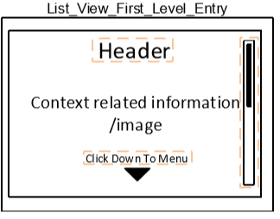

F-REQ-385236/A-List View: First_Level_Final

- Enter First_Level_Final from First_Level_Entry after ‘List_IOD_Timeout(t1)’ expires.
- Pressing the left or right button on the steering wheel, while being in lower list levels (from list level two and below) jump to first List_Level_Final.

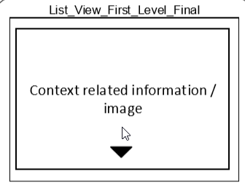

F-REQ-385237/A-List View: Second_Level_Bigstage

When in the list view, as you move up/down in a list, the item you are on will be highlighted to show you where you are in the list and will have “OK”, “OK>”, Checkbox and Radio Button at the end of each item and “Close” at end of List.
- Customers can select menu items via steering wheel buttons up/down
- First list element is selected when entering the state.
- Customer must press HK_OK on steering wheel, to start the selected action.
- Selected items are graphical highlighted.
- Items can be greyed out. In this case, they can be select (highlighted), but pressing the button “OK“ will not lead to an action

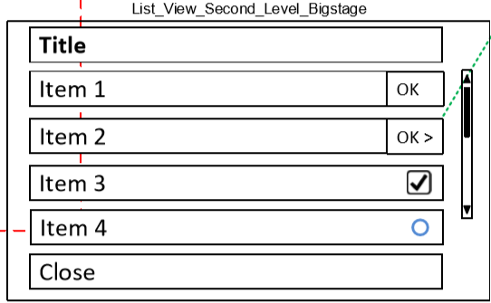

F-REQ-385238/A-List View: Second_Level_Bigstage- Scrollbar & Close Button
- Scrolling UP and Down triggered by HK_UP/ HK_down / Scrolling behavior: page wise
- Wrap around behavior in all list levels (Level 2, 3, 4…)
- Close Button only at second list level, from third list level back button with same behavior
- Close Button is always at the end of the list (e.g. if list would consist of 5 items and a close button, the close button would be at the top of page 2)

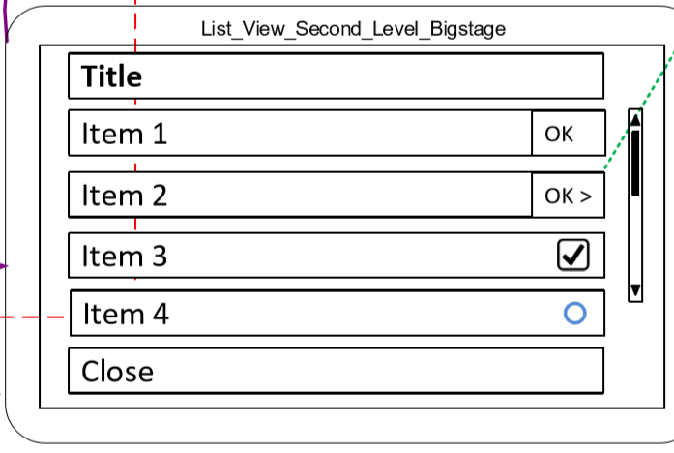

F-REQ-385239/A-List Items
Items in lists can have following functionalities/ characteristics:

- BTN_OK (item 1) start an action (e.g. open a special view, see Item 1)
- BTN_OK_Arrow (item 2) open a submenu (see item 2)
- Checkbox enabling/disabling a function (see item 3)
- Radio button enabling/disabling a sub function. Radio buttons of one function exclude each other (see item 4 & 5)
- Maximum of 5 items per page

Note: All BTN actions are triggered by HK_OK

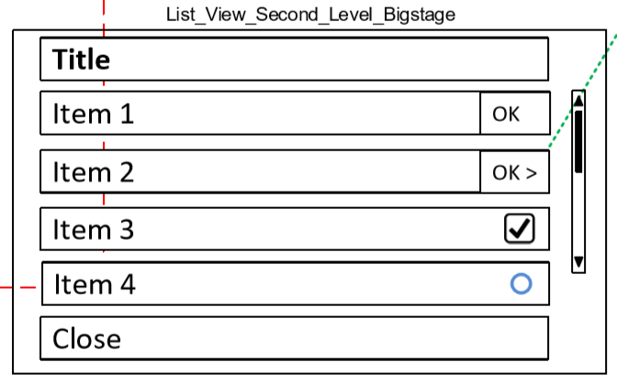

F-REQ-385240/A-List View: Left-Right Button behavior at different levels
- Pressing the left or right button on the steering wheel, while being in lower list levels (from list level two and below) jump to first list level.
- Pressing the left or right button on the steering wheel, while being in the first level Jump to another domain (see Menu_Main).

F-REQ-385241/A-Menu behavior for lower levels
All following menu levels (4,5,6…) have the same behavior:
- BTN_Arrow opens next menu level
- BTN_Back opens previous menu level

F-REQ-385242/A-Item Selection
To select an item in a list on a tab, Timeout for timer ‘List_IOD_Timeout(t1)’ will take you to a graphic page ‘List_View_First_Level_Final’ List that represents the item you have selected. i.e. selection of “Trip 1” will show you the Trip 1 graphic. Once you select an item and begin seeing the graphical view, Up/Down/OK presses will move you to second level of list.

F-REQ-385243/A-Up/down movement in a list
As you move up/down in a list, the list will wrap to the beginning or end depending on whether you are moving up or down.

F-REQ-385244/A-Maximum 5 items in the List

If there are more than 5 items in a list, scroll bar will be shown on the screen to indicate you have additional content. Scroll bar will not be displayed for five or less items.

F-REQ-385245/A-Settings tab
The Settings tab principally operates the same as other tabs but as you select an item and go deeper into a tab, another list will occur rather than showing a graphic. For many items you can go several levels deep with an “OK” press.

F-REQ-385246/A-Speed Locked Setting
Certain settings within the cluster will be restricted while vehicle is in motion due to regulatory requirements or system requirements. Settings that are speed locked shall “grey out” when above the speed threshold and shown not in “grey out” when speed goes below threshold. For example, the customer is within a submenu and speed goes from below to above speed threshold, confirmation will be shown that speed is above the threshold and setting not available. After confirmation shown, menu shall change to the parent menu item of the submenu previously in and the menu item should be “grey out”. Menu setting that should be speed locked will be documented in the vehicle specific HMI specification (ex Menu or Model). If room available, preference is to have lock symbol before the menu item to identify that menu settings as speed locked.

F-REQ-385247/A-The instrument cluster will Not remember the Last Active Page
The instrument cluster will not remember the Last Active Page and When leaving Lists on lower levels and reentering them within a clamp 15 cycle, jump always to first level of last active List.

F-REQ-385248/A-Menu Level numbering convention
Menu Level numbering convention: Tabs are numbered 1 through MaxTab, where MaxTab is the total number of Tabs. Tab x is a generic representation of any tab in the menu structure. Tab x-1 is to the left of Tab x. Tab x+1 is to the right of Tab x.

F-REQ-385249/A-LA_Page Definition

LA_Page = Last Active Page. The IPC will navigate to the Last Active Page when the Welcome scene completes.

LA_Page = Last_Active_IOD || Last_Active_List_First_Level

F-REQ-385250/A-Up/Down Message Center button presses functions

Up/Down Message Center button presses cycle the menu top/bottom unless otherwise indicated.

F-REQ-385252/A-Top Level and Sub-menu State Diagrams Symbols

| = or
/ = then
-> = transitions to

Notes for Tab Structure Top Level and IOD

F-REQ-385253/A-The instrument cluster will remember the Last Active IOD Page

The instrument cluster will remember the Last Active IOD Page and When leaving IOD’s and reentering them within a clamp 15 cycle, Jump into last screen. If last screen was a final state, jump into related IOD entry state

F-REQ-385254/A-IOD_Entry_Level to IOD_Final_Level Transition

When timer ‘List_IOD_Timeout(t1)’ expires on IOD_x_Entry screen or OK button is pressed It will take you to page ‘IOD_x_Final’ IOD that represents the item you have selected.

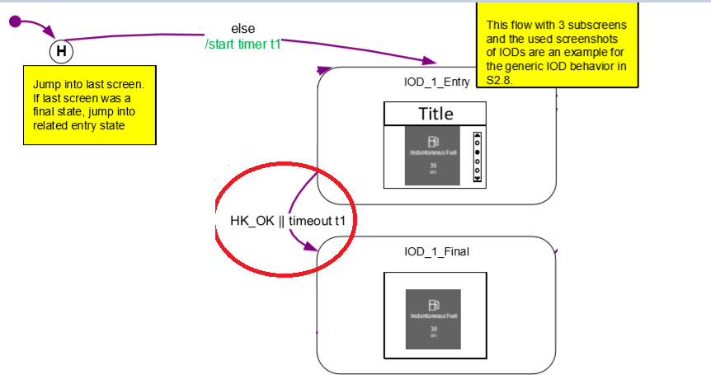

F-REQ-385255/A-IOD_x to IOD_x+1 Transition

- Down button press on IOD_x_Entry or IOD_x_Final will take it to IOD_x+1_Entry screen and triggers the ‘List_IOD_Timeout(t1)’ timer.
- UP button press on IOD_x_Entry or IOD_x_Final will take it to IOD_x+n_Entry screen and triggers the ‘List_IOD_Timeout(t1)’ timer where (x+n) is last IOD screen. In this e.g. IOD_3 is last IOD.

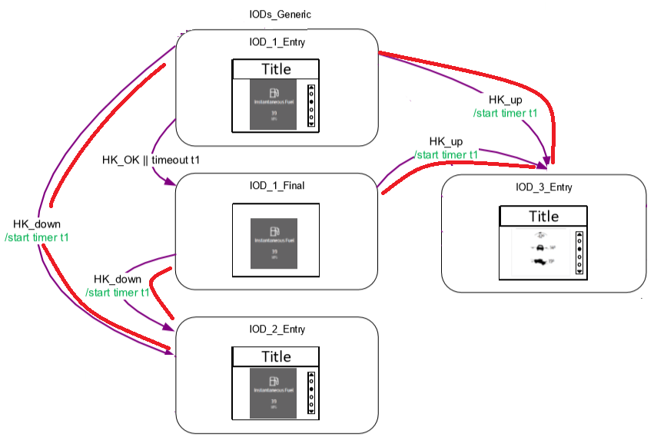

F-REQ-385256/A-IOD_x to IOD_x-1 Transition

- UP button press on IOD_x_Entry or IOD_x_Final will take it to IOD_x-1_Entry screen.
- Down button press on last IOD IOD_n_Entry or IOD_x_Final will take it to IOD_1_Entry IOD screen (Wrap around behavior). In below example n (last IOD) =3.

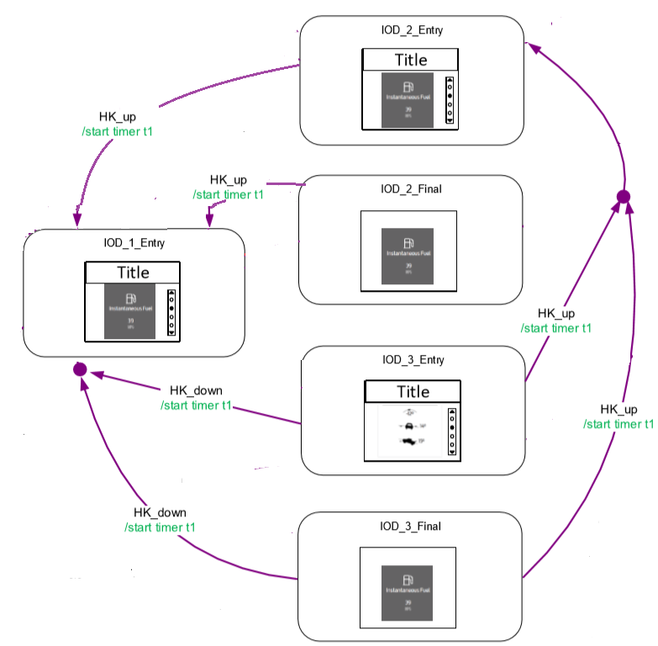

F-REQ-385257/A-IOD Reset Behavior
- Resettable IOD’s can be reset by press and hold OK button for Two seconds.
- If OK button is released before two seconds, it will abort the reset process.
- IOD reset will be shown through reset indicator.

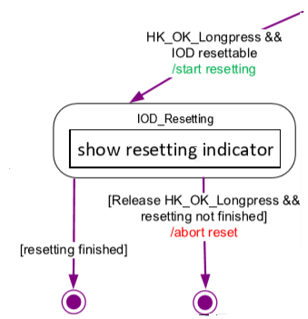

F-REQ-385258/A-IOD Pagniation

- OK button press on IOD_x_Final page will take it to IOD_x+1_Final page, if Final page and Pagniation is available.
- Wrap around behavior for all available IOD Final pages which have Pagination available.

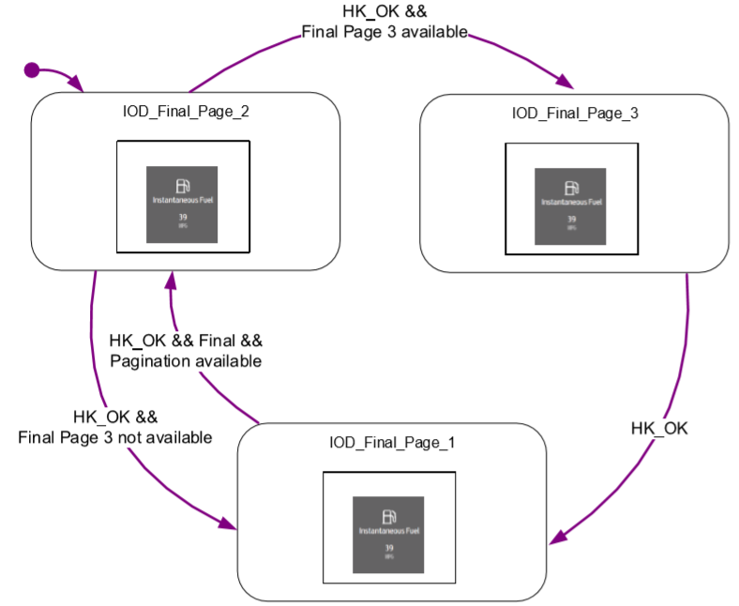

F-REQ-385259/A-IOD Pagniation Exit

UP or DOWN button press will end Pagniation and will take it to main menu.

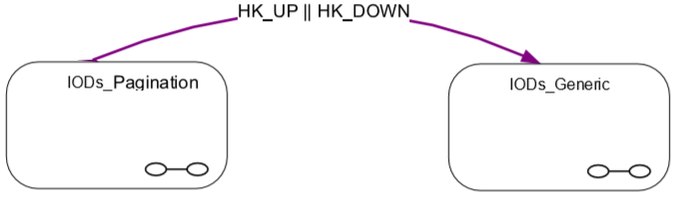

Notes for Speed Locked Settings State Diagrams

F-REQ-385260/A-Level X represents a sub-menu of the previous level

Level X represents a sub-menu of the previous level. This logic structure is repeated as often as necessary until the lowest level of the menu is achieved. The logic structure of the lowest level is slightly different and is as depicted in the Sub-Menu Display Logic Diagram. An OK button press will follow the Last Active Path.

F-REQ-385261/A-Menu Level numbering convention

Menu Level numbering convention: Capital letters (ex. X, Y, Z) represent the Menu Level number. Lower case letters (ex. w, x, y, z) represent the maximum number of sub-menus a given menu level can have. For example, Level X Display 1 can have sub-menus in Level Y numbered 1.1 – 1.y₁, where the subscript number to y (in this case 1) represents the parent level's display number. Similarly, Level X Display x_{w} can have sub-menus in Level Y numbered x_{w}.1 – x_{w}.y_{x}.

F-REQ-385262/A-LA_Page Definition

LA_Page = Last Active Page. The IPC will navigate to the Last Active Page when the Welcome scene completes

F-REQ-385263/A-LA_Path (#) Definition

LA_Path (#) = The last active path to a sub-menu from the (#) display.

F-REQ-385264/A-The Speed Locked Settings will not be accessible while driving

While in Settings, the “Speed Locked Settings” item will not be accessible while driving. This will be grayed out while driving. If an attempt is made to select it, a popup warning will appear indicating you must be stopped to access these settings. All other settings (items above Speed Locked Settings) are considered driver selectable features and will be useable while driving. The Speed_Locked_Setting_Flag is defined in the table of section 1.3.5.1.4.9 Speed_ Locked_Setting_Flag requirement. To enter a Speed Locked Setup Sub-menu, the Speed_Locked_Setting_Flag must be False. While in a Speed Locked Setup Sub-menu, if the Speed_Locked_Setting_Flag becomes True, the Speed Locked Setup Sub-menu will be exited, and the menu will navigate back to the point of entry.

F-REQ-385265/A-Popup_Timer Definition
Popup_Timer is a timer used to display a popup message.

F-REQ-385266/A-Up/Down Message Center button presses cycle the menu (top/bottom)
Up/Down Message Center button presses cycle the menu top/bottom unless otherwise indicated.

F-REQ-385267/A-Speed Locked Setting State Diagram Symbols

| = or
/ = then
-> = transitions to

F-REQ-385268/A-Speed_Locked_Setting_Flag

Operational Mode | VehVActlEng_D_Qf | Veh_V_ActlEng | Speed_Locked_Setting_Flag
Normal or  Crank | 0x2 (Not_Within_Specifications) |  0x3 (OK) | <5 km/h  (< 0x1F4) | False
Normal or  Crank | X | Missing as per 1.4.1 | True
Normal or  Crank | !(0x2 (Not_Within_Specifications) |  0x3 (OK)) | X | True
All Other Cases |  |  | True
X = Don’t Care

Notes for RTT State Diagram

F-REQ-385269/A-Fixed/Dedicated RTT Location

A Fixed/Dedicated RTT location (D: Dedicated RTT shown in fixed location) is a fixed location used to display a set of Active RTT’s that have Active states mutually exclusive of each other. There can be multiple Fixed/Dedicated RTT locations with different RTT sets assigned. Only the set of RTT’s specifically assigned to a Fixed/Dedicated RTT location can be displayed in that location. If all RTT’s in the set are Inactive, the Fixed/Dedicated RTT location will be blank. The Fixed/Dedicated RTT location does not cycle with the General RTT bank.

F-REQ-385270/A-Non-Toggle RTT location

A Non-Toggle RTT location (RF: small RTT in fixed non-rotating position (non toggle)) is like a Fixed/Dedicated RTT location. A Non-Toggle RTT Location is a fixed location used to display a set of Active RTT’s that have Active states mutually exclusive of each other. There can be more than one Non-Toggle RTT location if there is at least one General RTT location available that can toggle. The Non-Toggle RTT locations do not cycle with the General RTT bank when a Non-Toggle RTT is Active. If all RTT’s in the set of RTT’s specifically assigned to the Non-Toggle RTT location are Inactive, then the location is used in conjunction with the General RTT bank to display all other Active RTT’s and cycles accordingly.

F-REQ-385271/A-General RTT

A General RTT (R: small RTT rotating) is an RTT that is not assigned to either a Fix/Dedicated or Non-Toggle RTT location. A General RTT will be displayed in the General RTT bank. There must be a minimum of one General RTT location (i.e. the RTT bank cannot be filled with only Fixed/Dedicated and Non-Toggle RTT's).

F-REQ-385272/A-RTT Sets

RTT sets will be assigned to a Fixed/Dedicated RTT location based on program requirements and the following preference. Once all Fixed/Dedicated RTT locations have an RTT set assigned, the next highest RTT set can be assigned to a Non-Toggle RTT location, however, it is preferred that all status indicators are assigned to a Fixed/Dedicated RTT location or to a telltale and not to a Non-Toggle RTT location. The balance of the RTT’s will be displayed in the General RTT bank and cycled appropriately.

Example RTT sets for Fixed/Dedicated and Non-Toggle Locations
4x4 HIGH / 4x4 LOW / 4x2
Cruise Control / ACC
Tow Haul / Grade Assist / O/D OFF
E-Locker

F-REQ-385273/A-RTT_Cycle_Count

RTT_Cycle_Count is an incremental counter that represents the number of the present RTT cycle. This counter increments when the NWMD_Timer or WC_Timer expire, unless there is a reset condition. RTT_Cycle_Count is reset to 1 whenever there is a change in status for a General or Non-Toggle RTT (i.e. an RTT transitions to Active or Inactive) or all Active General RTT’s have been displayed.

F-REQ-385274/A-Active_RTT_Count

Active_RTT_Count is an incremental counter that represents the number of Active General RTT’s and includes only RTT’s that will be cycled. Non-Toggle and Fixed/Dedicated RTT’s are not included in this count because they do not cycle.

F-REQ-385275/A-Active_RTT (x)

Active_RTT(x) is a matrix of Active General RTT’s in order of activation. Newly active RTT's will be added to the end of the Active RTT list. Non-Toggle and Fixed/Dedicated RTT’s are not included in this matrix. Matrix elements without an Active RTT will be blank.

F-REQ-385276/A-Non-Toggle_Location_Flag

Non-Toggle_Location_Flag is set to indicate if a location in the General RTT bank is being used to display a Non-Toggle RTT. When a Non-Toggle RTT (RTT_{Non-Toggle}) is active, Non-Toggle_Location_Flag is set to 1.

F-REQ-385277/A-The number of Available RTT Location in the General RTT bank
n is the number of RTT locations available in the General RTT bank. Each location is labeled as RTT_{i} where i = 1 to n. m is the number of RTT locations available in the General RTT bank for use by General RTT's. p is the number of Active Non-Toggle RTT's. If there are no Active Non-Toggle RTT's then m = n. If there is an Active Non-Toggle RTT then m = n – p.

F-REQ-385278/A-RTT Activation order

It should be noted that because the active RTT’s are ordered in order of activation, their display location can change when a previously Active RTT transitions to Inactive.

F-REQ-385279/A-General RTT locations

General RTT locations are shown with a left-to-right numbering approach. Non-Toggle RTT's locations are numbered right-to-left. Non-Toggle RTT's should always be grouped together.

F-REQ-385280/A-Cycling page convention

This approach uses a cycling page convention when there are more active General RTT’s than there are locations in the General RTT bank.

F-REQ-385281/A-Newly Active RTTs Display

Newly Active RTT’s should be displayed immediately per the RTT Function flowchart, and not wait for any associated Message Center Warning to be displayed.

F-REQ-385282/A-RTT State Diagram Symbols

| = or
/ = then
-> = transitions to

Notes for Warning/Alert State Diagram

F-REQ-385283/A-Multiple Active new warnings

When there are multiple new warnings Active, the TA warning will be included in the warning cycle. When first displayed, it will display for the 2 second NWMD_Timer and set to Old. When the TA warning is displayed as Old, the WC_Timer shall be equal to the TA_Timer for the subject warning. This is done to accommodate TA warnings that have a time longer than the standard 4 seconds WC_Timer (i.e.10s or 30s).

F-REQ-385284/A-Ignition Status transitions to OFF

When the Ignition Status transitions to OFF, the TA_Timer for TA Warnings that are Active only in Normal Mode will be stopped and set to 0 such that the TA Warnings will not be redisplayed when the Ignition Status returns to Run (i.e. Normal Mode) unless the Warning_Status_Flag is Active for said TA Warning.

F-REQ-385285/A-TA type warnings that can be Active in both Limited and Normal Mode

When a TA type warning that can be Active in both Limited and Normal Mode is made Active in Limited Mode, the TA_Timer will be Reset and Start upon the warning being displayed in Normal Mode if the timer was not allowed to Expire before Ignition transitions to Run/Start. The warning will not be displayed during bulb Proveout unless an exclusion is specified.

F-REQ-385286/A-Global Alerts (RGA and NGA)

Global Alerts (RGA and NGA) will immediately overwrite other warning messages. The highest ranked Active Not-Reset Global Alert will be displayed and will not cycle. The Global Alert will be displayed as long as conditions are True or until it is Reset, if applicable.

F-REQ-385287/A-Multiple pages within warning are considered one warning

Multiple pages within warning would be considered one warning, not multiple warnings.

F-REQ-385288/A-Multiple page warnings Arbitration

Multiple page warnings will have same arbitration strategy with Global Alerts as single page warnings.

F-REQ-385289/A-Multiple page warnings display

Multiple page warnings will display the first page each time it is displayed (i.e. as a new warning or cycling with old warnings).

F-REQ-385290/A-Warnings that contain multiple pages

Warnings that contain multiple pages will use page wise scrolling between pages and contain a scroll bar on right hand side indicating which page is displayed. Pages do not automatically scroll.

F-REQ-385291/A-Warnings that contain selections
Warnings that contain selections will use line wise scrolling between selections. Selections do not automatically scroll.

F-REQ-385292/A-The last page of a warning that contain selections is entered

Each time the last page of a warning that contain selections is entered, the highlight will select the default selection.

F-REQ-385293/A-Selection options

Selection options are all contained on the last page (i.e. not spread through multiple pages).

F-REQ-385294/A-Types of multiple page warning

Multiple page warning can be TA/TA*/SC/SC*/NR type.

F-REQ-385295/A-Type which is not applicable to multiple page warning

Multiple page warning cannot be Global Alert type
.

F-REQ-385296/A-Pages Wrap Capability

Pages will not wrap.

F-REQ-385297/A-Selection Wrap Capability

Selections will not wrap.

F-REQ-385298/A-Down press when selections are not on the page

Down press will go to the next page when selections are not on the page.

F-REQ-385299/A-Down press when selections are on the page

Down press will go to then next selection if selections are on the page.

F-REQ-385300/A-Up press when selections are not on the page

Up press will go to the previous page when selections are not on the page.

F-REQ-385301/A-Up press when selections are on the page

Up press will go to the previous page if selections are on the page and scrim is on the top selection.

F-REQ-385302/A-Up press when selections are on the page

Up press will go to the previous selection if selections are on the page and scrim is not on the top selection
.

F-REQ-385303/A-Ok press when selections are on the page

OK press will go to the next page when selections are not on the page.

F-REQ-385304/A-Ok press when selections are on the page

OK press on last page will reset resettable warnings and action the selection if selections are on the page.

F-REQ-385305/A-Up/Down/OK press

Up/Down/OK press will reset the WC_Timer and TA_Timer, if applicable.

F-REQ-385306/A-P Definition

#P – Number of pages in the warning.

F-REQ-385307/A-#S Definition

#S – Number of selections in the warning, with #S = 0 indicating no selections in the warning.

Warning Cycle Examples:

F-REQ-385215/A-Example 1:
TA and SC warnings become active at the same time with the TA warning having the higher priority and a 10 second time.
Time | Display | Warning Status
0 | TA | Active + New becomes Active + Old
2 | SC | Active + New becomes Active + Old
4 | SC | Active + Old
6 | TA | Active + Old (will display for full 10 second TA time) becomes Reset
16 | SC | Active + Old (displayed until Reset or Inactive)

F-REQ-385216/A-Example 2:
SC is active and the TA becomes active (after 1 sec) with 10 second TA time and lower priority than the SC.
Time | Display | Warning Status
0 | SC | Active + New becomes Active + Old
2 | TA | Active + New becomes Active + Old
4 | TA | Active + Old (will continue to be displayed for WC_Timer (TA_Timer length = 10 sec)) become Reset
12 | SC | Active + Old (displayed until Reset or Inactive)

F-REQ-385217/A-Example 3:
TA1 has priority 1 (highest) with 10 second TA time
SC has priority 2
TA3 has priority 3 (lowest) with 10 second TA time
Warnings become active at the same time.
No button actions.
Time | Display | Warning Status
0 | TA1 | Active + New becomes Active + Old
2 | SC | Active + New becomes Active + Old
4 | TA3 | Active + New becomes Active + Old
6 | TA3 | Active + Old (will continue to be displayed for WC_Timer (TA_Timer length = 10 sec)) becomes Reset
14 | TA1 | Active + Old (will display for TA_Timer length =10 sec ) becomes Reset
24 | SC | Active + Old (displayed until Reset or Inactive)

F-REQ-385219/A-Warning logic During Prove out:

Note: Warning logic should not be processed during Bulb Proveout except for the warnings listed in F-REQ-319174. This is necessary to prevent warnings from being inadvertently activated by other modules during power-up. The warnings that are processed during Bulb Proveout will be displayed when they become Active and will not wait for the Welcome scene

F-REQ-385312/A-Screen Confirmation Reference

Screen_Confirmation = True only for screens that have a confirmation message upon completion of some action (ex. Change in Setup menu setting).

F-REQ-385313/A-Checkbox_Timer Definition

Checkbox_Timer is a timer used to display the screen with updated check box status prior to displaying confirmation message.

F-REQ-385314/A-Popup_Timer Definition

Popup_Timer is a timer used to display a popup message.

F-REQ-385315/A-Status_Timer Definition

Status_Timer is a timer used to display status message upon completion of some action (ex. Reset Complete)

F-REQ-385316/A-Number of Active Warnings Variable

g = number of Active Warnings for System Check (if applicable).

F-REQ-385317/A-Up/Down Message Center button presses functions

Up/Down Message Center button presses cycle the menu top/bottom unless otherwise indicated.

F-REQ-385318/A-Checkbox Delay

When the Checkbox Delay is displayed, the display will show the selected item highlighted. The checkbox will indicate actual system status. The confirmation message will be displayed when the Checkbox_Timer expires.

F-REQ-385484/A-Warning / Alert Logic Diagram

F-REQ-385489/A-Warning Displayed (Scrolling) Logic Diagram

F-REQ-385494/A-Reconfigurable Telltale (RTT) Display Logic Diagram

F-REQ-385483/A-Button Press Scroll_Up_Rq

F-REQ-385435/A-Button Press Scroll_Down_Rq

F-REQ-385324/B-Warning Message ID’s to be process during Bulb Proveout

MC Warning Message ID | Reference STSS
W600 | Warning - Passive Entry Passive Start Immobilizer CGEA1.3_vX.X / Warning – Starting System – CGEA 1.3
W609 | Warning - Passive Entry Passive Start Immobilizer CGEA1.3_vX.X / Warning – Starting System – CGEA 1.3
W630 | Warning - Passive Entry Passive Start Immobilizer CGEA1.3_vX.X
W636 | Warning - Passive Entry Passive Start Immobilizer CGEA1.3_vX.X
W641 | Warning - Passive Entry Passive Start Immobilizer CGEA1.3_vX.X
W645 | Warning - Passive Entry Passive Start Immobilizer CGEA1.3_vX.X
W648 | Warning - Passive Entry Passive Start Immobilizer CGEA1.3_vX.X
W590 | Warning – Starting System – CGEA 1.3
W591 | Warning – Starting System – CGEA 1.3
W3532 | Warning - Passive Entry Passive Start Immobilizer CGEA1.3_vX.X
W3100 | Warning - Passive Entry Passive Start Immobilizer CGEA1.3_vX.X
W601 | Warning – Starting System – CGEA 1.3
W4362 | Warning - Passive Entry Passive Start Immobilizer CGEA1.3_vX. X / Warning – Starting System – CGEA 1.3
W4363 | Warning - Passive Entry Passive Start Immobilizer CGEA1.3_vX. X / Warning – Starting System – CGEA 1.3
W4365 | Warning - Passive Entry Passive Start Immobilizer CGEA1.3_vX.X / Warning – Starting System – CGEA 1.3
W4367 | Warning - Passive Entry Passive Start Immobilizer CGEA1.3_vX.X / Warning – Starting System – CGEA 1.3
W4364 | Warning – Starting System – CGEA 1.3
W4366 | Warning – Starting System – CGEA 1.3
W589 | Warning – Starting System – CGEA 1.3

F-REQ-385325/A-Speed_Locked_Setup_MC_Status_Flag to MC Warning Message ID

Speed_Locked_Setup_MC_Status_Flag | MC Warning Message ID | Active Chime_Status_Flag
Active | W3428 | None

F-REQ-385434/A-High Level State Diagram

F-REQ-385433/A-Logic Diagram for Tab Structure Main Menu

F-REQ-385432/A-Logic Diagram for Tab Structure LISTS

F-REQ-385431/A-Logic Diagram for Tab Structure IOD’s Generic

F-REQ-385430/A-Logic Diagram for Tab Structure IOD’s Pagination

F-REQ-385429/A-Hold OK Time Bar Logic Diagram

F-REQ-385428/A-Sub-Menu Display Logic Diagram for Speed Locked Setup features

Operation Description (supports algorithm flowchart /state diagram)

F-REQ-385335/A-All Displays

All Displays – This document defines "superset" content. Specific vehicle content may not include all content defined in this document.

F-REQ-385336/A-Setup Menu
In the Setup Menu, when a system is not available due to a fault condition, the Setup menu for that system will be grayed out (if possible, in the hardware) and not selectable. A feature with a Disabled configuration will not appear in the Setup Menu.

F-REQ-385337/A-Last Active Page (LA_Page)

The IPC will display the Last Active Page (LA_Page) upon completion of the Welcome strategy.

LA_Page = LA_Active_IOD || LA_Active_List_First_Level

FS-REQ-385377/A-Function Safety Classification (EMC)

All Message Center functionality is Functional Safety Classification B.

Memory Storage

NVM-REQ-385378/A-Warning Flags

Each warning shall have RAM flags to identify the following:
- Warning Category
- Reset or Not-Reset
- Chime or No-Chime
- Active or Not-Active
- New or Old

NVM-REQ-385379/A-Timer Definitions Table

 |  | Timers shall be programmable within the following range : *
Timer Name | Duration | Description | Min | Max | Resolution
NWMD_Timer | 2 s | "New Warning Minimum Display Timer". Minimum duration that a New Text Warning must be displayed. | 0 s | 7 s | 1 s
List_IOD_Timeout(t1) | 1s | Duration after which List or IOD will move to next/Final level | 0s | 5s | 1s
WC_Timer | 4 s | "Warning Cycle Timer". Duration that each warning will be displayed when multiple Active warnings are all Old. If a TA or TA* warning has a non-default value, then the WC_Timer shall be equal to the TA_Timer for the subject warning. | 0 s | 31 s | 1 s
TA_Timer | 4 s | "Temporary Alert Timer". Defines the display length for TA and TA* warnings. Each warning can have a unique TA_Timer length. See WC_Timer definition. | 0 s | 31 s | 1 s
Status_Timer | 2.0 s | Duration that a Status message will be displayed | 0 s | 4 s | 100 ms
Popup_Timer | 1.5 s | Duration that a Popup message will be displayed | 0 s | 4 s | 100 ms
Checkbox_Timer | 500 ms | Duration that a "Checked" selection will be displayed before displaying a Popup confirmation message. | 0 s | 1 s | 100 ms
* Note: Timers must be programmable to at least the Max value listed. Higher Max values and finer resolutions are acceptable.

NVM-REQ-385380/A-Parameter Definitions

Parameter Name | Description | Value at  Battery Connect | Value at Module Wake-up
ETM | Internal variable indicating if the instrument cluster is in Engineering Test Mode (ETM) | False | False
ScreenPause(#) | Internal variable indicating if Screen (#) is paused. Separate variables will be maintain for each screen (#) with PauseFunction(#) = True | False | Do not Init
Non-Toggle_Location | Internal variable indicating if a location in the General RTT bank is being used to display a Non-Toggle RTT. | 0 | 0
RTT_Cycle_Count | An incremental counter that represents the number of the present RTT cycle. This counter increments when either the NMWD_Timer or WC_Timer expires unless there is a reset condition. RTT_Cycle_Count is reset to 1 whenever there is a change in status for a General or Non-Toggle RTT (i.e. an RTT transitions to Active or Inactive) or all Active General RTT’s have been displayed. | 1 | 1
Active_RTT_Count | An incremental counter that represents the number of Active General RTT’s and includes only RTT’s that will be cycled. Non-Toggle and Fixed/Dedicated RTT’s are not included in this count because they do not cycle. | 0 | 0
Active_RTT(x) Matrix | Active_RTT(x) is a matrix of Active General RTT’s in order of activation. Non-Toggle and Fixed/Dedicated RTT’s are not included in this matrix. Matrix elements without an Active RTT will be blank. | 0 | 0
RTT_{Non-Toggle} | A variable that represents the state of the set of RTT's assigned to the Non-Toggle RTT location. | Inactive | Inactive
M | A variable that represents the number of RTT locations available in the General RTT bank for use by General RTT's | n | n
Veh_V_ActlEng | Vehicle speed as received over CAN | 0x0 | 0x0
VehVActlEng_D_Qf | Quality factor of vehicle speed as received over CAN | No_Data_Exists (0x1) | No_Data_Exists (0x1)
Speed_Locked_Setting_Flag | Used to control entry to/exit from Speed_Locked Setup features | False | False
Speed_Locked_Setup_MC_Status_Flag | Used to control the state of the warning to the Message Center arbitrator | Inactive | Inactive
Scroll_Down_Rq | Variable indicating when a menu should scroll down based on a button press or hold. | False | False
Scroll_Up_Rq | Variable indicating when a menu should scroll up based on a button press or hold. | False | False
#P | Number of pages in the warning. | 1 | 1
#S | Number of selections in the warning, with #S = 0 indicating no selections in the warning. | 0 | 0
Warning_Page | Currently displayed page of the warning. | 1 | 1
Warning_Selection | Current selection within the warning | 1 | 1
Cycle_Warning | Flag indicating when the next Active Not-Rest warning should be displayed (ex. OK press on last page of NR warning, WC_Timer = Expired). | False | False
Clamp 15 cycle | Ignition Cycle | NA | NA

Prove-Out

Message Center Display Prove-Out

Reference Welcome-Goodbye STSS.

Reconfigurable Telltale Prove-Out

The Reconfigurable Telltale shall remain blank during the Welcome Mode.

Error Handling

Missing Message Strategy

Diagnostics

Self Test
None

F-REQ-385382/A-Engineering Test Mode
Reference Text Message List – SHMI Display STSS section for minimum content requirements of Engineering Test Mode. The Cluster supplier is free to include additional content in Engineering Test Mode.

Part II Performance

Supported Diagnostic Trouble Codes (DTCs)

DTC | Description | When Logged
None

DID-REQ-385381/A-DID DExx

Block  Num | Block Description | Size (bits) | Type | Byte(s) | Bits | State: Description | "0" | "1" | Default | Comments/  Information
PACKETED BLOCKS
$02 | Option Content (B&A) | * | 1 | * | * | Speedometer Cal | Non-ECE | ECE | Non-EC | Non-ECE = U.S., Canada, Mexico  ECE = GCC, China, most export countries
*Byte and bit location to be identified in Part II Specification for this cluster

Reference Specification

- HMI Specifications:
  - Text: Program Master Warning Message List.xls | Program Translation Table.xls
  - Structure: Program Menu Structure.xls
  - Control Logic: Program HMIDialog_Diagram.pdf

Revision History
SPSS Module Revision History

Revision Level | Name | Change Description | Date
1.0 | H. Sharma | Initial Release
2.0 | J. Gregoire | Changes highlighted in Olive.  DI CC Approval: 6/11/2020  Lead program: P703 MY21  Change Requester: McNabb, Jamie (J.) jmcnabb4@ford.com  Feature Owner: Braithwaite, Paul (P.) pbraith1@ford.com  Signal Change: No  Change Request ID: 524  Change Request Description: Create alternative warnings that do not obscure Welcome Startup animation.  1.3.5.1.6.39 F-REQ-385324/A-Warning Message ID’s to be process during Bulb Proveout – Add new warnings. | 7/27/2020

